ASSINGMENT – 04

JOINING 2 TABLES USING JOIN CLAUSE

TYPES OF JOIN COMMANDS

1.Inner join

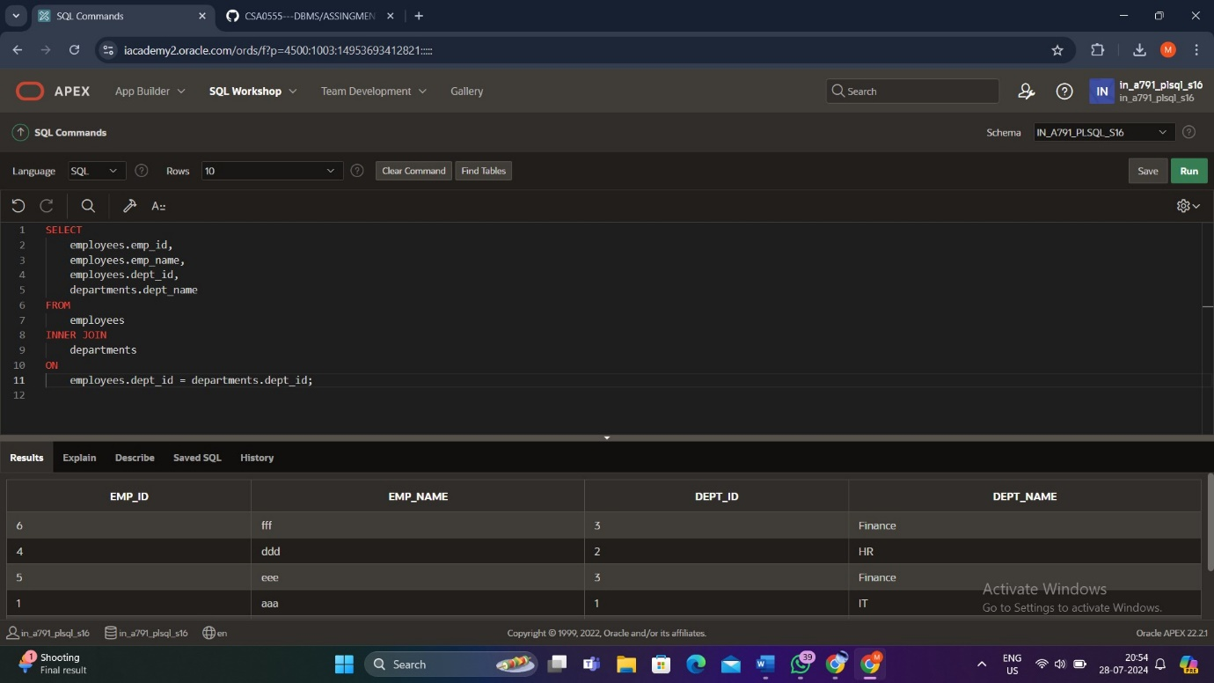

2.Left Outer Join

3.Full Outer Join

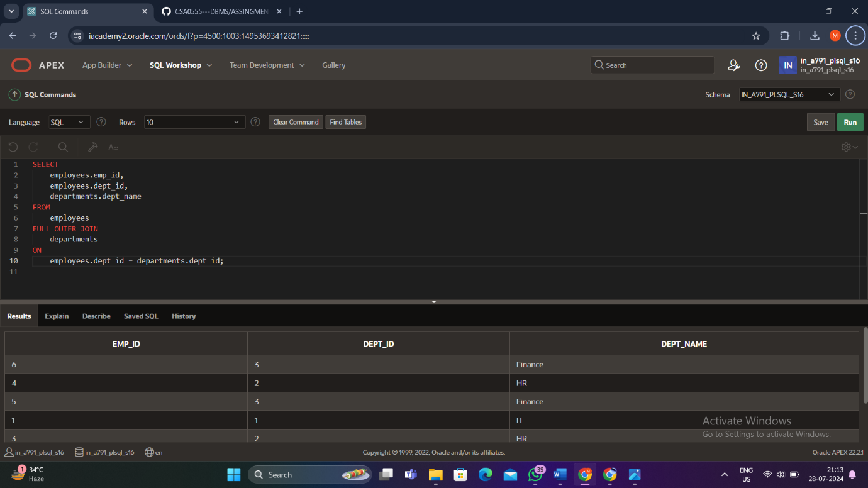

4.Left Join

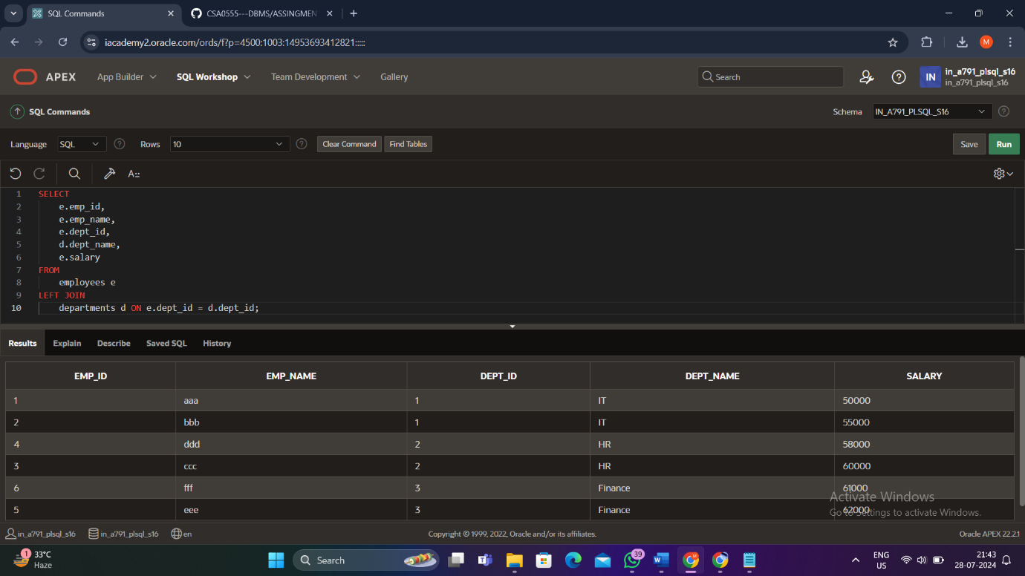

5.Self Join

